OFFICIAL COORDINATION REQUEST FOR
NON-ROUTINE OPERATIONS AND MAINTENANCE

COORDINATION TITLE- Bonneville MU1, 2, 9 & 10 Model Validation Testing
COORDINATION DATE- May 11, 2022
PROJECT- Bonneville Lock & Dam
RESPONSE DATE- May 18, 2022

Description of the problem – Model Validation testing is required for MU 1, 2, 9 & 10. This is standard work completed every 5 years per BPA. PH1 and PH2 are staggered 2-3 years apart to even the workload. This work had been planned for April but water levels were extremely low so it was postponed. Per FPP section 4.3 testing of priority units 1 & 10 should occur between December 1 and April 30, this coordination is for testing outside of that window.

Type of outage required - MU 1, 2, 9 & 10 will run out of priority for up to ~4 hours a day. Unit priority order will follow FPP table Bon-13.
PH1: 1,10,3,6,9,4,5,8,7,2

Impact on facility operation - Units may be operated out of priority. PH1 units may be operated before all PH2 units are on-line.

Dates of impacts/repairs - May 24-26
May 24th - units 1, 2
May 25th - units 9, 10
Potential retesting May 26th

Length of time for repairs: 4 hours per unit 1 hour offline, 1 hour speed no load, 1 hour mid load, 30 minutes max load, 30 minutes Return to Service.

Analysis of potential impacts to fish

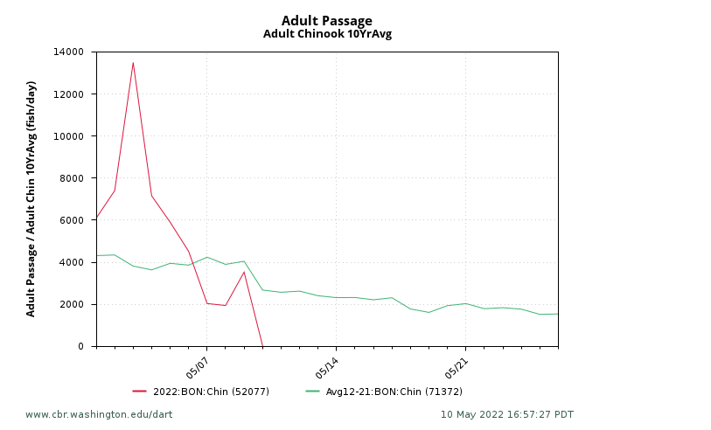
- 10-year average passage by run during the period of impact for adults and juvenile listed species, as appropriate for the proposed action and time of year.
Figure 1. 2022 adult Chinook passage to date, comparted to 10-year average of adult chinook passage. (Obtained from Columbia Basin Research, DART)
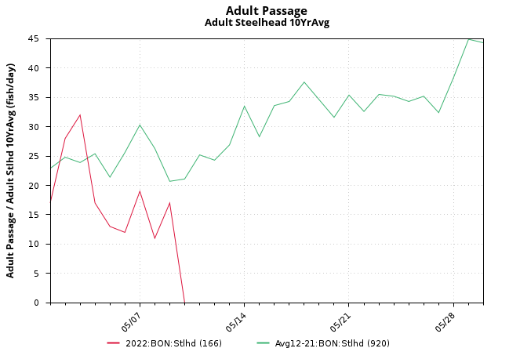
Figure 2. 2022 adult Steelhead passage to date, compared to 10-year average of adult Steelhead passage. (Obtained from Columbia Basin Research, DART)
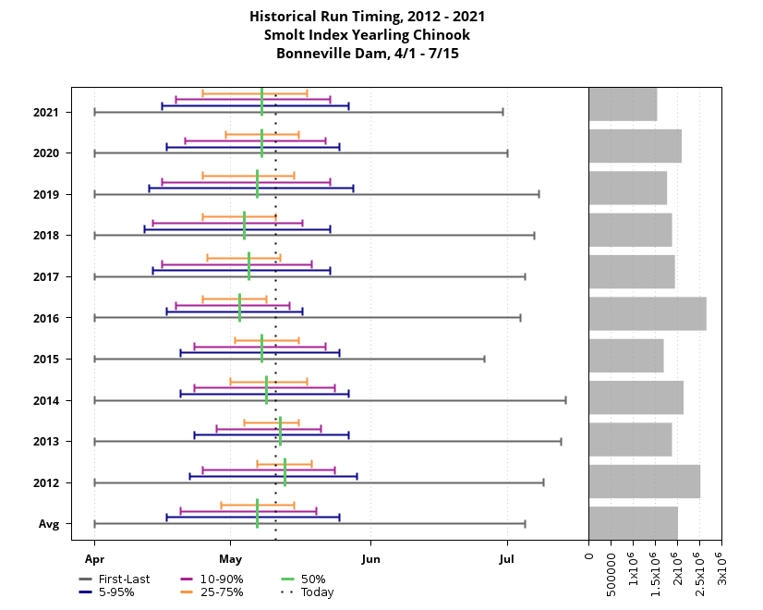
Figure 3. 10-year historical run timing of yearling chinook between April - July 15 (Obtained from Columbia Basin Research, DART)
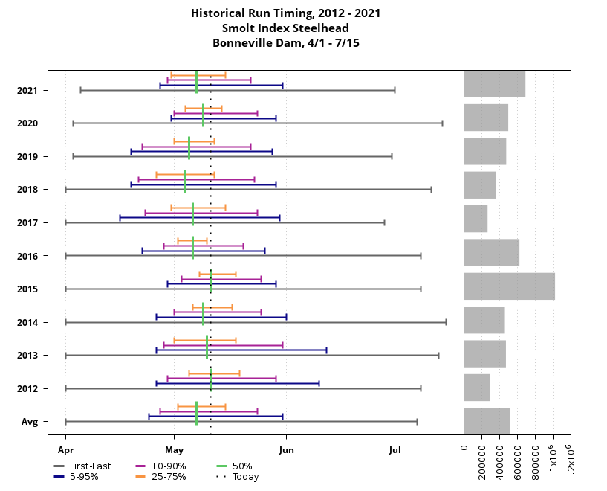
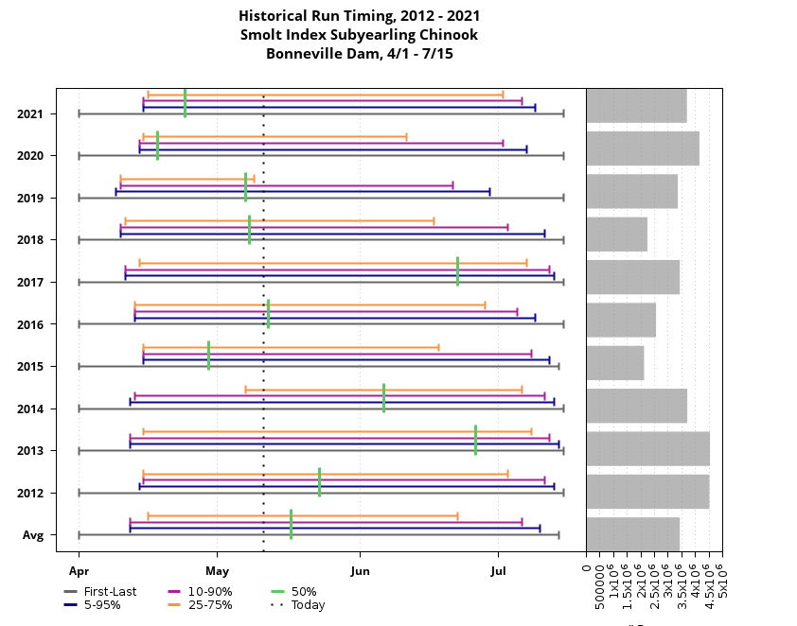
Figure 5. 10-year historical run timing of steelhead smolts between April 1 – July 15 (Obtained from Columbia Basin Research, DART)
Figure 4. 10-year historical run timing of Sub-yearling Chinook between April 1 – July 15 (Obtained from Columbia Basin Research, DART)
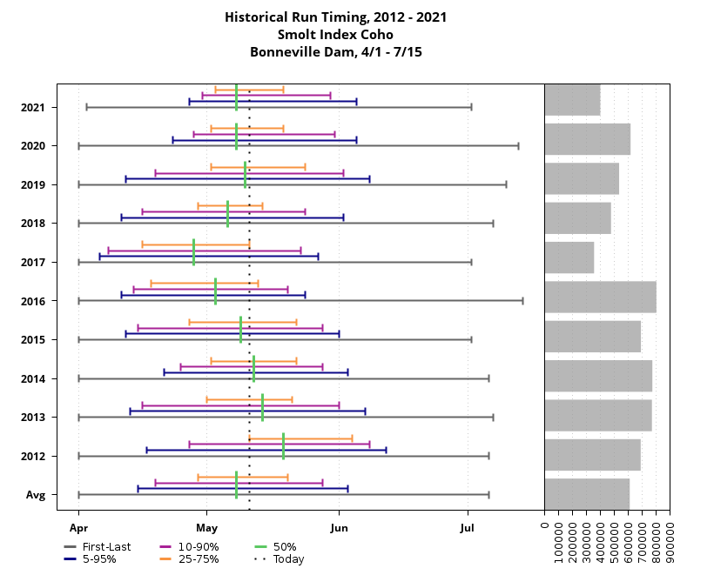
Figure 6. 10-year historical run timing of Coho smolts between April 1 – July 15 (Obtained from Columbia Basin Research, DART)
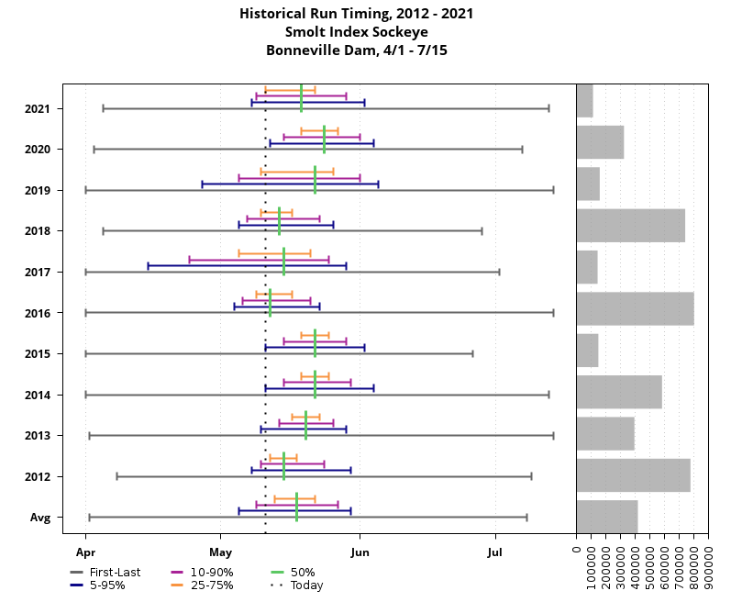
Figure 7. 10-year historical run timing of Sockeye smolts between April 1 – July 15 (Obtained from Columbia Basin Research, DART)

Lamprey were not included in a graph because this operation is not expected to have a major impact. Lamprey passage during this time of year is low and Bonneville has all LPS’s running as well as the LFS for optional passage routes.

- Statement about the current year’s run (e.g., higher or lower than 10-year average);
Table 1. Run Prediction Forecasts Obtained From WDFW.
Chinook | Similar to last year’s actual return
Sockeye | Below 10-year average
Coho | Above 10-year average
Steelhead | Below 10-year average

- Estimated exposure to impact by species and age class (i.e., number or percentage of run exposed to an impact by the action);
Due to the high number of juvenile fish passing at this time run percentage was not calculated.
- Type of impact by species and age class (increased delay, exposure to predation, exposure to a route of higher injury/mortality rate, exposure to higher TDG, etc.);
This operation will decrease attraction flow from units 1 and 10 for 1-2 hours. This may have a small impact on adult salmonids being attracted to fishway entrances and juvenile salmonids being attracted to north and south ITS (Ice and trash sluiceway) entrances. It is important to note that the next units also have ITS entrances which will mitigate some of this impact. The ITS will be in service providing adequate attraction flow.

Summary statement - expected impacts on:

Downstream migrants: The population of downstream migrants most likely to be impacted are the sub-yearling Chinook, this will be the largest population of salmonids at the time of testing. Other salmonid runs could also be impacted but it is not expected to have a major impact because of how brief of a time the testing occurs.

Upstream migrants: The impact is expected to be the greatest on the upstream migration of spring Chinook. Generally, the run of spring Chinook is tapering off at this point and Bonneville is passing around 2,000 fish a day. All fish ladders will be fully operational and only attraction flow will be affected momentarily.

Comments from agencies

From: Bettin,Scott W (BPA) - EWP-4 <swbettin@bpa.gov>
Sent: Wednesday, May 11, 2022 1:49 PM
To: Madson, Patricia L CIV USARMY CENWP (USA) <Patricia.L.Madson@usace.army.mil>
Cc: Mackey, Tammy M CIV USARMY CENWP (USA) <Tammy.M.Mackey@usace.army.mil>; Derugin, Andrew G CIV (USA) <Andrew.G.Derugin@usace.army.mil>
Subject: [URL Verdict: Neutral][Non-DoD Source] RE: FPOM Official Coordination: 22BON011 MOC Model Validation Testing

You’ll likely have someone point out that the goal is to get the testing done but not divert 10 kcfs of spill away from the spillway and run it through the turbine. Right now there is plenty of flow in the river and we will likely be able to do it without diverting flow from the spillway. The most likely outcome is that you will only have units running out of priority. -s

220514 FPOM draft meeting minutes

22BON011 MOC Model Validation Testing- Derugin wants to withdraw MOC and change test dates to August after juvenile runs have dropped off. Bettin thinks it would be better to do this test now as PH1 should be running later in May and there will be plenty of units running. Whereas in August there will not be a need to run PH1 and you’ll be turning units on just for this test. Bettin said a delayed run off will be coming. Conder asked about comment in MOC concerning shifting 10k from spillway. Derugin said if there was not enough flow and nothing at PH1 is running, reduce spill. Conder said swapping spill from a PH2 low priority unit would be better. Fish managers are thinking of trying to hit the 250 target at McNary sooner than later, plus spring freshets would provide flow. Conder said he is OK with August, and he would be ok with May if spill language is removed. Mackey said targeting spring flows would be best. Taking flow from spill is not acceptable unless only option, take PH2 low priority units first. Juveniles not impacted if you are not taking from spill. Spring is the better option than waiting for summer when you will impact operations. Derugin will let the MOC stand as is and remove reference to spill. Mackey asked for any additional comments. Van Dyke has no comment. Ebel has no comment.

Final coordination results

Model validation testing of Units 1,2,9 &10 will proceed as scheduled May 24-26, with expected impacts to unit priority during testing.

After Action

Please email or call with questions or concerns.
Thank you,

Andrew Derugin
Project Biologist – Bonneville Lock & Dam
Andrew.G.Derugin@usace.army.mil

Patricia Madson
Columbia River Coordination (acting)
Patricia.L.Madson@usace.army.mil

